Software Requirements Specification

for

MGMT WEB

Prepared by

Team Name:

Flávio Steffens de Castro – flavio.steffens@acad.pucrs.br

João Henrique Stocker – joao.pinto@acad.pucrs.br

William Tessaro Lunardi – william.lunardi@acad.pucrs.br

University: Pontifícia Universidade Católica do Rio Grande do Sul

Country: Brazil

10/10/2014

**Contents**

1 Introduction 4

1.1 Purpose 4

1.2 Scope 4

1.3 Definitions, Acronyms and Abbreviations 4

1.4 Overview 4

2 Overall Description 4

2.1 Product perspective 5

2.2 Product functions 5

2.3 User characteristics 6

2.4 Constraints 6

2.5 Assumptions and dependencies 6

3 Specific Requirements 6

3.1 Functional Requirements 7

3.2 Non-Functional Requirements 16

3.3 Use Cases 17

4 Supporting Information 19

4.1 Interface Prototypes 19

4.1.1 LOGIN 19

4.1.2 USER DASHBOARD 20

4.1.3 PROJECTS 21

4.1.4 PROJECT DASHBOARD 22

Revision History

|  |  |  |  |
| --- | --- | --- | --- |
| **Date** | **Version** | **Description** | **Author(s)** |
| 10/10/2014 | 1.0 | Creation of this document | Flávio, João, William |
| 13/10/2014 | 1.01 | Revision | Flávio |
| 20/10/2014 | 1.1 | Organizing the document | Flávio, João, William |

# Introduction

The following document will describe the web-based system called WEB MGMT, a professional system designed to help teams to collaborate and coordinate projects of their company.

Since the creation of Internet, the Computer Supported Cooperative Work (CSCW) systems are evolving to become more pervasive and easy to use for everyone, helping to maintain the awareness of each team member.

The WEB MGMT is a system that will help teams to achieve their goals in every kind of IT project.

## Purpose

The purpose of this document is to describe the requirements of the WEB MGMT, a web-based system to help distributed software development teams to work together and maintain the awareness of each team member about the projects that they are involved.

The main characteristics of this system are that it’s based on most of agile methods, specially Scrum, with most of the processes based upon its framework.

## Scope

What is in the scope of this WEB MGMT Document:

1. Identify the requirements that describe all the functionalities of the system, as the customer asked;
2. Create the Requirements Properties (RP) of each functionalities identified;
3. Create the Use Cases (UC) of the most important or complex functionalities;
4. Create a prototype for the interface of the User Dashboard and Project Dashboard;
5. Describe the non-functional requirements for the system.

What is NOT in the scope:

1. Any other case that is not formally expressed in the items above.

## Definitions, Acronyms and Abbreviations

CSCW = Computer Supported Cooperative Work

WBS = Work Breakdown Structure

UC = Use Cases

RP = Requirement Properties

NFR = Non-functional Requirement

NFRP = Non-functional Requirement Properties

MVP = Minimum Viable Product

## Overview

The next sections will describe more the requirements of the WEB MGMT. First, it will give an overall description of the system, and then will

# Overall Description

## Product perspective

The following Work Breakdown Structure (WBS) describes the main view of the WEB MGMT:

1. LOGIN
2. USER DASHBOARD
   1. Projects Overview
   2. General Statistics
3. USER MANAGEMENT (ADMIN ONLY)
   1. Create user
   2. Edit user
   3. Exclude user
4. PROFILE
   1. Edit profile
   2. Exclude profile
5. PROJECTS
   1. List projects
   2. Create & exclude projects
   3. Project Statistics
   4. Project Backlog
   5. Project Details & Information
   6. Impediments
   7. Sprint Backlog
   8. Task administration
   9. Task commentaries

## Product functions

In this section, we will give a brief overview of each of the sections and functions described above.

LOGIN

This is the section where the users will see when entering the WEB MGMT for the first time. They could create an account or access the system with a previous user / password confirmation. Also, they can reset their password, if it’s lost.

USER DASHBOARD

The user dashboard is the main page of the system. When the user log in, the system will show a resume of the users’ participation. Also, they will find here: projects and tasks assigned, general statistics, last login time, etc. This will work more like a “welcome” page getting the user updated of the status of the projects.

USER MANAGEMENT (ADMIN ONLY)

This functionality will be available only for the admin users. Here, they will be able to create, exclude and edit any of the users in the system. Only the admin users cannot be deleted.

PROFILE

In this section, the users will be able to update their personal information, like avatar, name, description, email, password, etc. Also, they can delete themselves from the system.

PROJECTS

This is the most important section of the system, and will be the base of this document. Here, the users will find all the data and information of the projects that they are assigned. It’s important to know that the “Project Dashboard” will not include ALL of the projects information, like the “User Dashboard”, but only those projects that they are assigned. In this dashboard, the user will be able to create, update and delete data from the project, making every action visible to other team members.

## User characteristics

The scope of the WEB MGMT will be based upon two kinds of users:

1. ADMIN
2. DEVELOPER
3. SYSTEM

Besides the “System” user, that will be an entity only specified to represent some system agents of the WEB MGMT, the other two users will be practically the same role. The only difference is that the ADMIN user can create, edit and exclude all of the users, and also have access to every kind of log that the system will be generating (not implemented in this version).

## Constraints

This is a Minimum Viable Product (MVP) for the MGMT system. As so, this document will describe only the essential functions that fits for this context. The system has some practices that are based upon the agile methods like Scrum. But it can be used for any kind of project, even with the PMI methodology.

## Assumptions and dependencies

For this document, we assume the following statements:

* + - 1. The system is for enterprise use
      2. Only members of the organization will have access to the system
      3. Every user has a minimum knowledge on the project management process
      4. All projects are visible to every member of the organization
      5. One member will be responsible for being the main user of the system (Admin)

# Specific Requirements

This section contains all software requirements both functional and non-functional. This table below is called Requirment Properties (RP) and describes an example of how the requirements will be described in the following sections:

|  |  |
| --- | --- |
| **Requirement ID** | Uniquely identifies requirement |
| **Title** | Gives the requirement a symbolic name |
| **Description** | The definition of the requirement |
| **Priority** | Defines the order in which requirements should be implemented. Priorities are designated (highest to lowest) from 1 to 3. Requirements of priority 1 are mandatory; 2 represents features nice to have, and 3 represents optional features. |
| **Risk** | Specifies the risk of not implementing the requirement. It shows how critical the requirement is to the system as a whole. The following risk levels are defined over the impact of not being implemented correctly.   * Critical (C) It will break the main functionality of the system. The system cannot be used if this requirement is not implemented. * High (H) It will impact the main functionality of the system. Some function of the system could be inaccessible, but the system can be generally used. * Medium (M) It will impact some system features, but not the main functionality. The system can still be used with some limitation. * Low (L) The system can be used without limitation, but with some workarounds. |

.

## Functional Requirements

**LOGIN**

|  |  |
| --- | --- |
| **Requirement ID** | RP 001 |
| **Title** | The user should create an account as “developer” |
| **Description** | As a generic user, they could be able to access the “Login” page and click on the “Create your Account” button, filling a form with basic information. Since the system is an enterprise version, every created user will be a part of the organization. |
| **Priority** | Priority 1 - Mandatory |
| **Risk** | * This requirement’s risk is CRITICAL for the system. Every user needs to have an account to access the information of the projects of the organization. |

|  |  |
| --- | --- |
| **Requirement ID** | RP 002 |
| **Title** | The user should log in into the system |
| **Description** | As a signed user, he should be able to access their user dashboard just entering his user (email based) and password. |
| **Priority** | Priority 1 - Mandatory |
| **Risk** | * This requirement’s risk is CRITICAL for the system. Every user needs to have an account to access the information of the projects of the organization. |

|  |  |
| --- | --- |
| **Requirement ID** | RP 003 |
| **Title** | The user should recover his password |
| **Description** | If a user forget his user or password, he should be able to recover his user (email) or password by clicking a button called “Forgot your login?”. The system will send a message to the admin users to help the users to recover their informations. |
| **Priority** | Priority 1 - Mandatory |
| **Risk** | * This requirement’s risk is HIGH for the system. The functionality if very important for the user, but not mandatory. |

**USER DASHBOARD**

|  |  |
| --- | --- |
| **Requirement ID** | RP 004 |
| **Title** | The system must show the user activities and tasks |
| **Description** | As a signed user, he will access his user dashboard. In this interface he will see an overview of the tasks for each project that he is assigned. Each of the tasks will be shown in the following subsections:  DOING – showing the tasks that the user is assigned and are still in the doing swim lane of the projects;  TO DO – showing the tasks that the user is assigned and are still in the todo swim lane of the projects.  Also, the system will show some basic statistics of the projects, like:  Total Active Projects, Tasks that were finished in the the last week; Tasks that were finished today; Tasks that have impediments. |
| **Priority** | Priority 1 - Mandatory |
| **Risk** | * This requirement’s risk is CRITICAL for the system. Every user needs to have an account to access the information of the projects of the organization. |

|  |  |
| --- | --- |
| **Requirement ID** | RP 005 |
| **Title** | The system must show the user profile summary |
| **Description** | As a signed user, he will be able to see his username in the top of the system, also showing his last login date. |
| **Priority** | Priority 2 – Nice to Have |
| **Risk** | * This requirement’s risk is LOW for the system. This kind of information is good to have, but not so important. |

|  |  |
| --- | --- |
| **Requirement ID** | RP 006 |
| **Title** | The user should access the project dashboard of the tasks visible in his user dashboard |
| **Description** | As a signed user, he will see all the tasks that he is assigned in his user dashboard. It’s important that he can access the respective project dashboard only by clicking the respective link on each tasks, called “View Project”. |
| **Priority** | Priority 1 - Mandatory |
| **Risk** | * This requirement’s risk is CRITICAL for the system. Every user needs to have an account to access the information of the projects of the organization. |

|  |  |
| --- | --- |
| **Requirement ID** | RP 007 |
| **Title** | The user should access the task administration screen of each task in his user dashboard |
| **Description** | As a signed user, he will see all the tasks that he is assigned in his user dashboard. It’s important that he can administrate the respective tasks only by clicking the respective link on each task, called “Edit”. |
| **Priority** | Priority 1 - Mandatory |
| **Risk** | * This requirement’s risk is CRITICAL for the system. Every user needs to have an account to access the information of the projects of the organization. |

**USER MANAGEMENT**

|  |  |
| --- | --- |
| **Requirement ID** | RP 008 |
| **Title** | The admin user can create any user |
| **Description** | Only the admin user can access this section.  The admin user can create an user by clicking the “Create user” button. The form shown will have the following information:  Name, email, password, confirm password, avatar picture. |
| **Priority** | Priority 1 - Mandatory |
| **Risk** | * This requirement’s risk is CRITICAL for the system. |

|  |  |
| --- | --- |
| **Requirement ID** | RP 009 |
| **Title** | The admin user can edit any user |
| **Description** | Only the admin user can access this section.  The admin user can edit an user by clicking the “Edit user” button. The form shown will have the following information:  Name, email, password, confirm password, avatar picture. |
| **Priority** | Priority 1 - Mandatory |
| **Risk** | * This requirement’s risk is CRITICAL for the system. |

|  |  |
| --- | --- |
| **Requirement ID** | RP 010 |
| **Title** | The admin user can delete any user |
| **Description** | Only the admin user can access this section.  The admin user can delete an user by clicking the “Delete user” button. The form shown will have the following information:  Name, email, password, confirm password, avatar picture. |
| **Priority** | Priority 1 - Mandatory |
| **Risk** | * This requirement’s risk is CRITICAL for the system. |

**PROFILE**

|  |  |
| --- | --- |
| **Requirement ID** | RP 011 |
| **Title** | A user should change his avatar photo |
| **Description** | A user can be able to change his profile picture, by clicking on “Edit Profile” and uploading an image with at least 100 pixels of size, in each side. |
| **Priority** | Priority 2 – Nice to Have |
| **Risk** | * This requirement’s risk is LOW for the system. |

|  |  |
| --- | --- |
| **Requirement ID** | RP 012 |
| **Title** | A user should change his personal information |
| **Description** | A user can be able to change his information by clicking on “Edit Profile” and editing the forms that the system present: name, email, password, confirm password. |
| **Priority** | Priority 1 – Mandatory |
| **Risk** | * This requirement’s risk is CRITICAL for the system. |

**PROJECTS**

|  |  |
| --- | --- |
| **Requirement ID** | RP 013 |
| **Title** | The system must list the existing projects |
| **Description** | By clicking on the “Projects” option, the system will list all the projects that are created, listed as “In progress” and as “Finished”.  The projects will have the following information:  Name, client and a button to view the project dashboard. |
| **Priority** | Priority 1 – Mandatory |
| **Risk** | * This requirement’s risk is CRITICAL for the system. |

|  |  |
| --- | --- |
| **Requirement ID** | RP 014 |
| **Title** | A user should be able to create a new project |
| **Description** | By clicking on the “New Project” button, the system will show a form with the information of the new project. The following information will be required:  Name, client, deadline date, and the user that created the project will have the power to delete the project. |
| **Priority** | Priority 1 – Mandatory |
| **Risk** | * This requirement’s risk is CRITICAL for the system. |

|  |  |
| --- | --- |
| **Requirement ID** | RP 015 |
| **Title** | A user should be able to view the project dashboard |
| **Description** | By clicking on the “view” button, of the listed projects, a user will be able to see the project dashboard with all the information of the system. |
| **Priority** | Priority 1 – Mandatory |
| **Risk** | * This requirement’s risk is CRITICAL for the system. |

|  |  |
| --- | --- |
| **Requirement ID** | RP 016 |
| **Title** | The system must show the project dashboard |
| **Description** | The project dashboard is similar to the agile scrum dashboard, with the following structure of swim lanes:  Backlog, that will contain all the tasks that are created by the users and are not yet assigned or planned to be in production (can represent the product backlog);  To Do, that will contain all the tasks that are created and planned to be worked in the next days (can represent the sprint backlog);  Doing, that will contain all the tasks that are assigned to someone and are in progress;  Done, that will contain all the tasks that are finished by someone. |
| **Priority** | Priority 1 – Mandatory |
| **Risk** | * This requirement’s risk is CRITICAL for the system. |

|  |  |
| --- | --- |
| **Requirement ID** | RP 017 |
| **Title** | A user should create a new task |
| **Description** | When a user click on the “New task” button, the system will present a popup screen with a form about the task. The information required will be:  Task title (name of the task), assigned to (the developer that is assigned to the task), estimation (a number that will represent the effort estimation of the task – could be points, hours, etc), deadline (the date of the deadline), status (to inform the status of the task – see RP 019) and commentaries (every user can comment the task). |
| **Priority** | Priority 1 – Mandatory |
| **Risk** | * This requirement’s risk is CRITICAL for the system. |

|  |  |
| --- | --- |
| **Requirement ID** | RP 018 |
| **Title** | A user should change the status of the task |
| **Description** | The tasks will have a status associated. The following status are options to be selected:  Normal (default)  Important (for important tasks) – the task will be labeled with the yellow color  Stopped (for tasks that have an impediment associated) – the task will be labeled with the red color. |
| **Priority** | Priority 1 – Mandatory |
| **Risk** | * This requirement’s risk is CRITICAL for the system. |

|  |  |
| --- | --- |
| **Requirement ID** | RP 019 |
| **Title** | A user should comment in the tasks |
| **Description** | The main communication between users, in the system, will be by the commentaries in the tasks. The comments are very useful because each task will have a history of every commentary, so the users can discuss about them separately.  Also, the comments are very useful when the task is marked as “Stopped”, so everyone can see what impediment that is associated with the task. |
| **Priority** | Priority 1 – Mandatory |
| **Risk** | * This requirement’s risk is CRITICAL for the system. |

|  |  |
| --- | --- |
| **Requirement ID** | RP 020 |
| **Title** | A user could set a deadline for the task |
| **Description** | The deadlines of the tasks can help the users to plan and prioritize the most important and critical tasks. |
| **Priority** | Priority 1 – Mandatory |
| **Risk** | * This requirement’s risk is HIGH for the system. |

|  |  |
| --- | --- |
| **Requirement ID** | RP 021 |
| **Title** | A user should assign someone for the task |
| **Description** | Each task must have someone associated with. This version of the MGMT will support only one user per task. |
| **Priority** | Priority 1 – Mandatory |
| **Risk** | * This requirement’s risk is CRITICAL for the system. |

|  |  |
| --- | --- |
| **Requirement ID** | RP 022 |
| **Title** | A user should edit and update a task |
| **Description** | When the task is created, the user should have the option to click on the existing task to edit and update it. |
| **Priority** | Priority 1 – Mandatory |
| **Risk** | * This requirement’s risk is CRITICAL for the system. |

|  |  |
| --- | --- |
| **Requirement ID** | RP 023 |
| **Title** | A user should delete a task |
| **Description** | When the task is created, the user should have the option to delete it. The delete option will be available in the pop up screen with the information of the tasks (when the RP 022 is actived). |
| **Priority** | Priority 1 – Mandatory |
| **Risk** | * This requirement’s risk is CRITICAL for the system. |

|  |  |
| --- | --- |
| **Requirement ID** | RP 024 |
| **Title** | A user should move the tasks between the swim lanes |
| **Description** | The users can change the status of progression of the tasks by drag and drop the selected task between the swim lanes of the dashboard. |
| **Priority** | Priority 1 – Mandatory |
| **Risk** | * This requirement’s risk is CRITICAL for the system. |

|  |  |
| --- | --- |
| **Requirement ID** | RP 025 |
| **Title** | A user should be able to edit and update the project information |
| **Description** | The users can edit the information of the active project by clicking on the “Info” button, in the side of the name of the project. |
| **Priority** | Priority 2 – Nice to have |
| **Risk** | * This requirement’s risk is MEDIUM for the system. |

|  |  |
| --- | --- |
| **Requirement ID** | RP 026 |
| **Title** | The system must show the statistics of the active project |
| **Description** | When in the project dashboard, the system must show the statistics of the project, below the dashboard screen. These statistics will be some graphs and information like:  Total tasks, total finished tasks, number of users associated to the project, burndown chart, etc. |
| **Priority** | Priority 2 – Nice to have |
| **Risk** | * This requirement’s risk is MEDIUM for the system. |

|  |  |
| --- | --- |
| **Requirement ID** | RP 027 |
| **Title** | The system must show important information of each task |
| **Description** | Each task will have a template that will be shown in its body. Here’s the template for it:  Label (for the colors that represent the status of the task)  Task name  Number of comments  Deadline date  User associated |
| **Priority** | Priority 1 – Mandatory |
| **Risk** | * This requirement’s risk is CRITICAL for the system. |

|  |  |
| --- | --- |
| **Requirement ID** | RP 028 |
| **Title** | A user should log off anytime |
| **Description** | The user must have the option to log off from the system anytime in the system. |
| **Priority** | Priority 1 – Mandatory |
| **Risk** | * This requirement’s risk is CRITICAL for the system. |

## Non-Functional Requirements

The NFRs for the MGMT system are:

* + - 1. The database must support at least 10.000 registers in this first MVP;
      2. The server must support at least 10 simultaneous requests at time;
      3. The server and the database must have a response time at least 500ms;
      4. The system must be installed and created by the ADMIN user;
      5. The server must have support to daily automatics backups;
      6. The system must be created using web-based tools;
      7. The system must be mobile-friendly. In other words, the webpages must work in smartphones and tablets;
      8. The webpages must be designed using the W3C standards;
      9. The dashboards should be programmed using an asynchronous method, so that when someone changes the dashboard, all the other users will see it in almost real time.

## Use Cases

The requirements above are represented by the following use cases:

**Users**

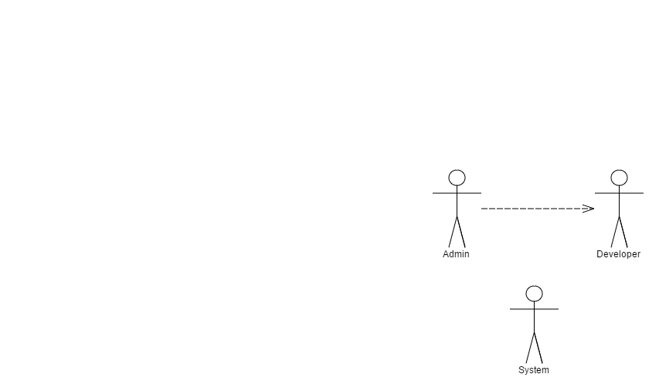

**Admin User**

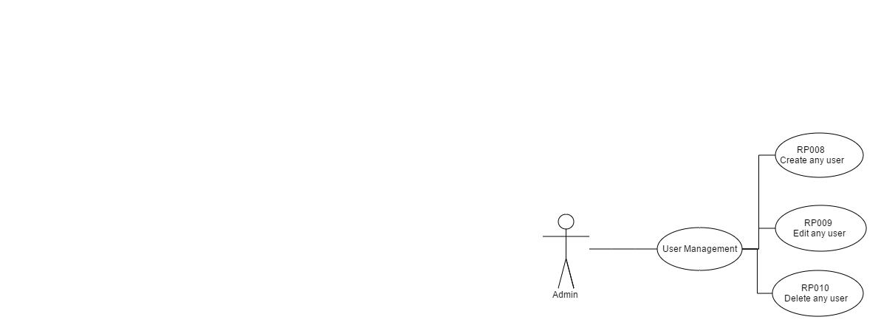

**System**

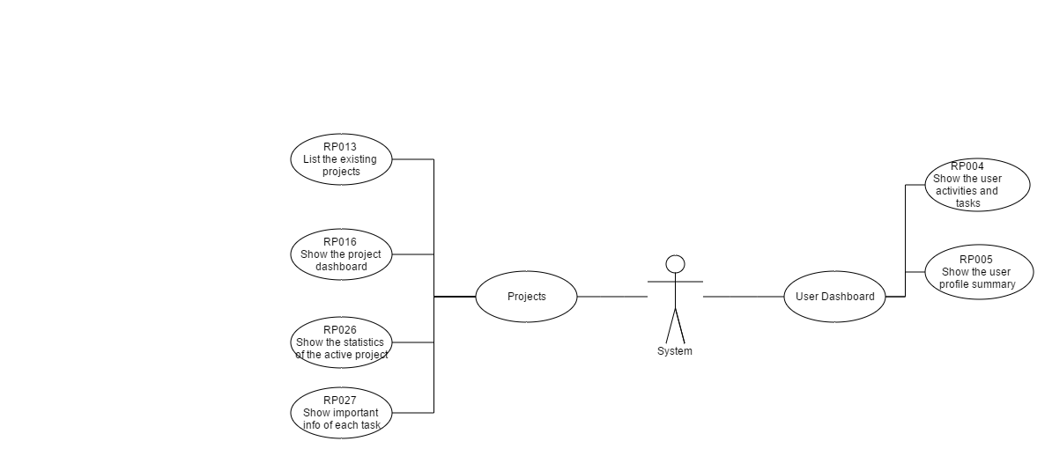

**Developer User**

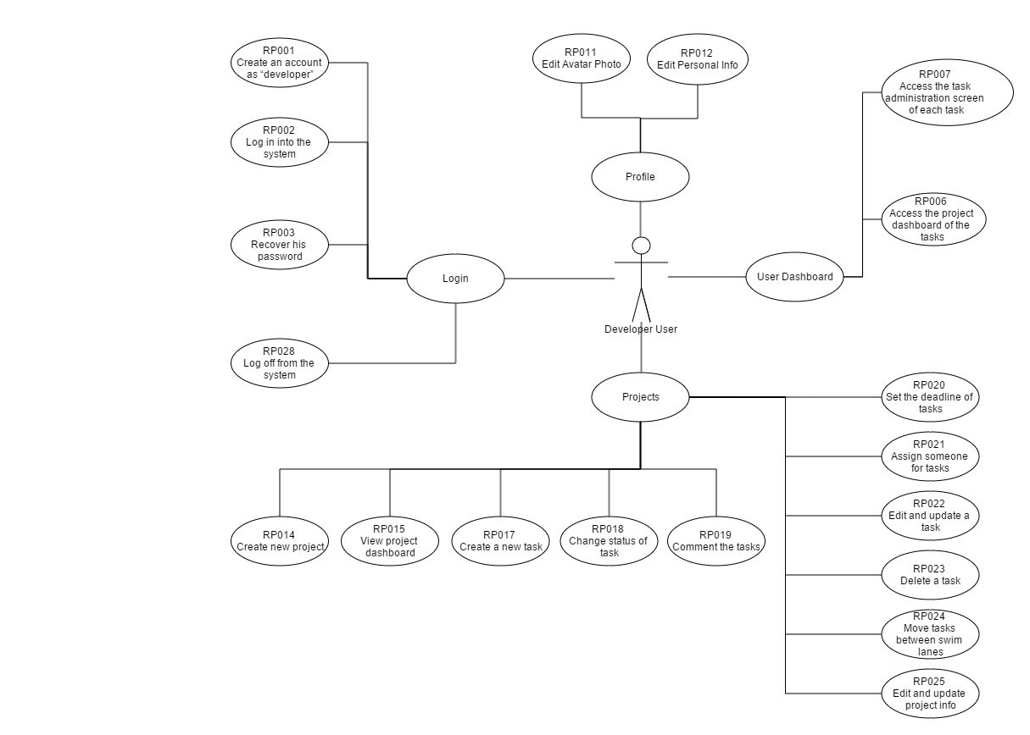

# Supporting Information

## Interface Prototypes

The following section will present a prototype for the most important interfaces of the system.

### LOGIN

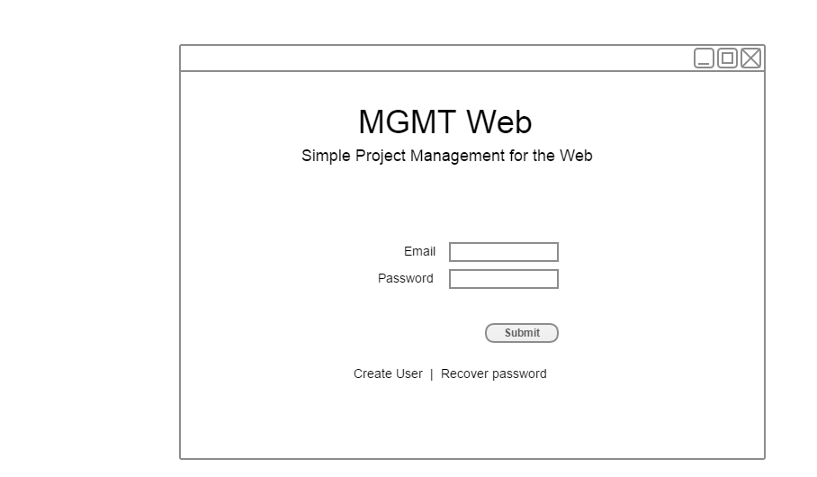

### USER DASHBOARD

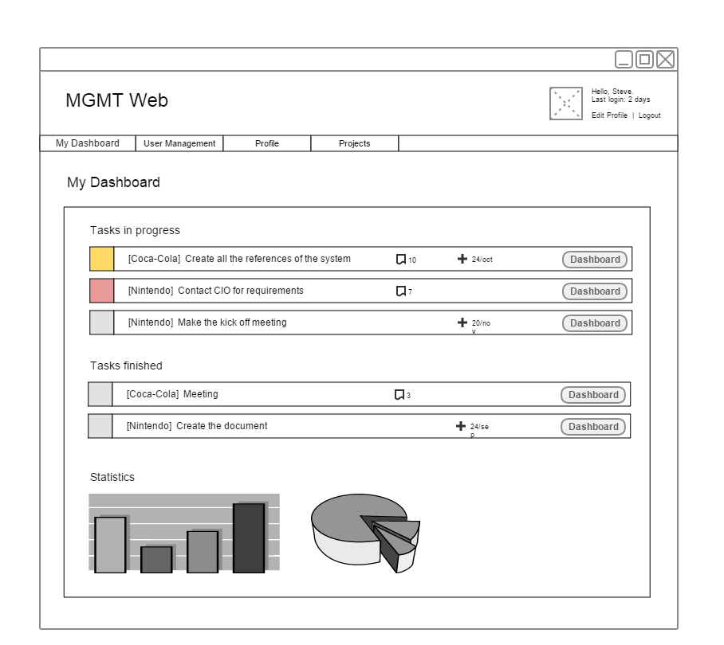

### PROJECTS

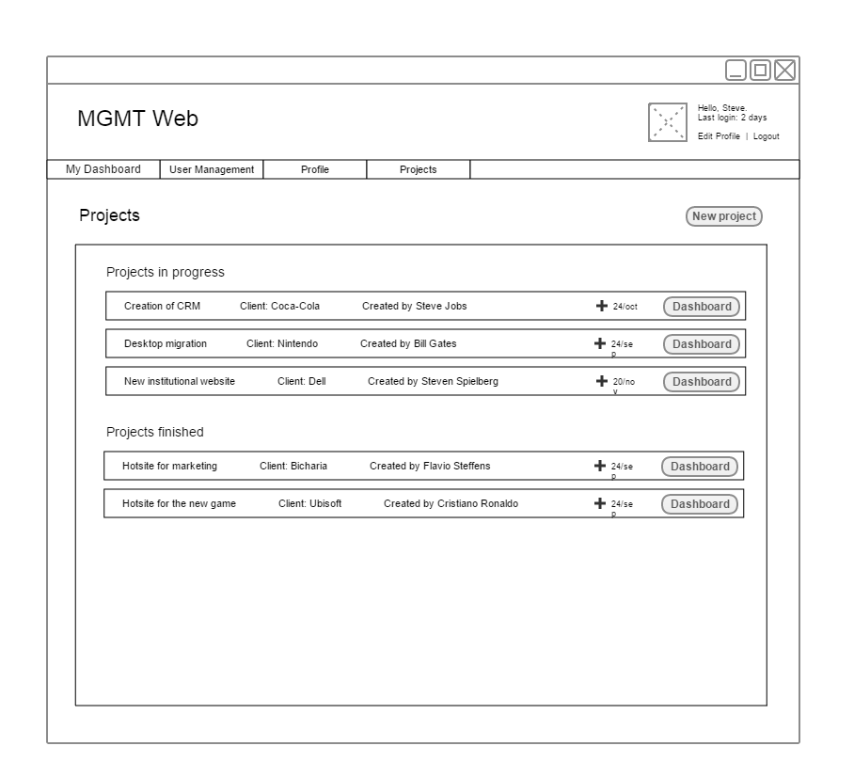

### PROJECT DASHBOARD

